

LITE Functional Review

Detailed Analysis of Services, Workflows and Processes  
Robert Taylor  
November 14th, 2020

Contents

1 Executive Summary 4

1.1 Original Charter 4

2 Analysis 4

2.1 System Level 4

2.2 Example Use Case – Simple Upload 4

2.3 HL7 + PACS Image Linking 4

2.3.1 Breaking Condition – HL7 + PACS Image Timing Problem 4

3 Unknowns 11

4 Glossary of Terms 11

# Executive Summary

LITE is an application that is critical to the transferring of data between systems for Life Image. This analysis will be conducted for the purposes of understanding the underlying business processes and procedures.

## Original Charter

To understand and analyze the existing functional implementations of the workload. The objective of this documentation is to outline the existing processes and highlight any weak areas in the functional implementation.

# Analysis

The main purpose of the system is to interconnect data systems from RIS, HIS, EMR and EHR data systems. LITE is configured to handle HL7 and DICOM data formats between these systems, and then upload that data into Life Image’s Cloud service. The interconnectedness can operate in both directions, where manipulations and annotations performed on the Cloud service can also be pushed back into the PACS or RIS systems.

## System Level

The LITE agent is installed on a target system that is hosted by the customer. The system can be Linux or Windows based, as long as it is able to operate a .NET service. The intended design of the system is to be able to operate under the following conditions.

* LITE must be able to run on shared resources in a single system
* LITE can be tuned to operate in more performant systems
* LITE should be able to run multiple instances at the same time, each configured with their own profiles
* LITE should run as a background service

Beyond these capabilities, issues such as networking and systems configuration are up to the customer to manage. The customer may engage a Life Image Deployment Support Engineer to perform the initial configurations in conjunction with a customer IT administrator.

In **Figure 1**, the general overview of the system is outlined, in which the LITE agent is installed in the client site and is configured to connect to a designated Life Image Cloud service. The existing architectural diagram can be found on **Figure 3**.

## Example Use Case – Simple Upload

In **Figure 2**, we can see a sequence diagram outlining events that can occur in this sample scenario. In this event, it showcases how LITE can be updated or configured through its polling mechanism against Cloud. Most UI elements that a user can interact with will be driven by Cloud, and the configuration changes are pulled by LITE into its own systems.

The configuration itself will then drive what to do with *messages* it receives from the various systems. In this context, *messages* mean a system pushing information such as DICOM or HL7 information into LITE. Once LITE receives these messages, it will queue the work for processing the message. The configuration drives how to route and process the information provided.

## HL7 + PACS Image Linking

It is possible to link together HL7 and DICOM image data from a PACS system together into a single study. That process is time based, and is outlined in **Figure 4, 5 and 6**. The systems could be working in conjunction to upload a single Study as defined in an HL7 report into Cloud. LITE and Cloud will operate together to ensure that the images are properly linked into a single packaged study. At the end of the process, Cloud will potentially send that packaged Study to its final destination.

### Breaking Condition – HL7 + PACS Image Timing Problem

It is possible for Cloud to have validated and closed a Study, and then there is an attempt to add an image to that study. When this occurs, the potential problem arises as the study has now been closed and is no longer able to accept changes. This is due to the fact that the study may have already been sent to its final destination.

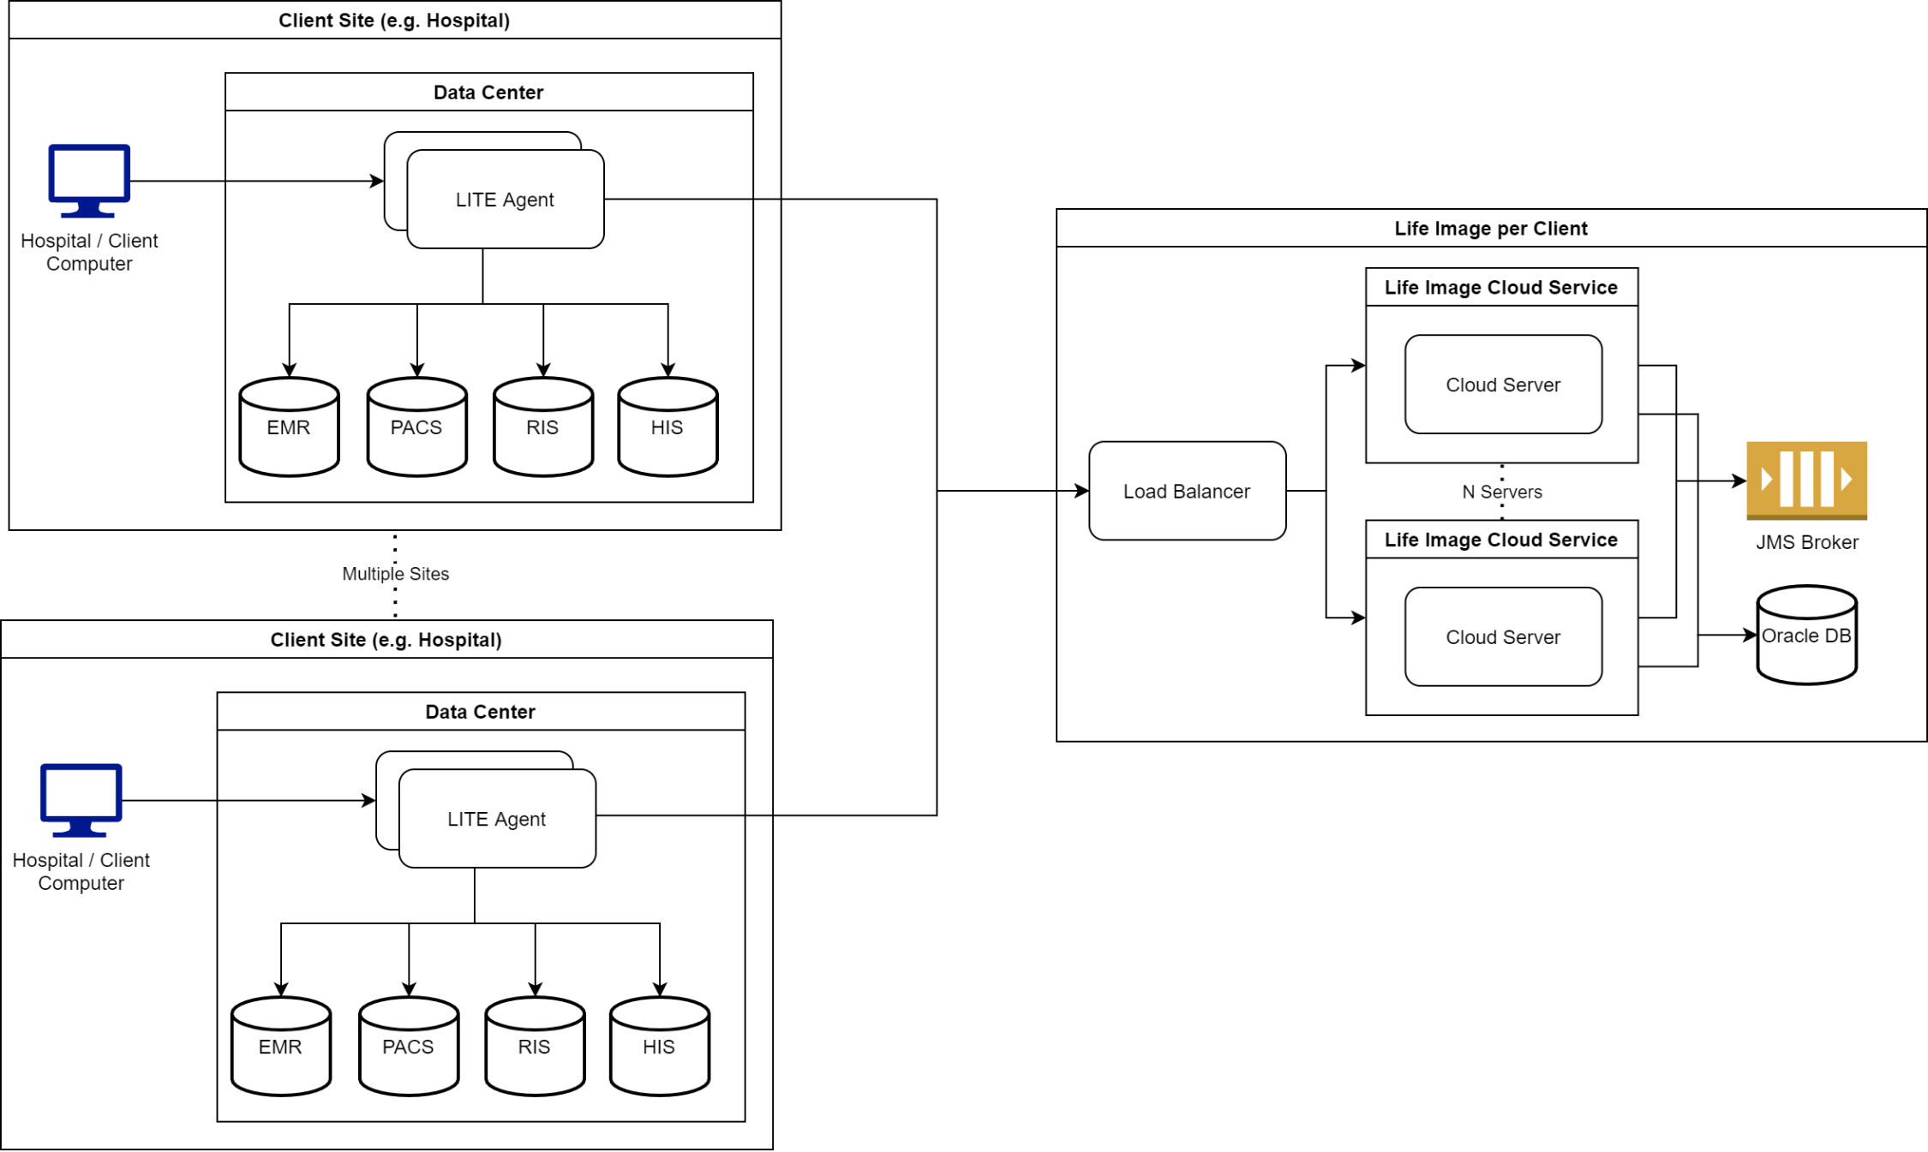

**Figure 1:** Understood systems level overview of the LITE agent as it relates to client systems and the configured Life Image Cloud service

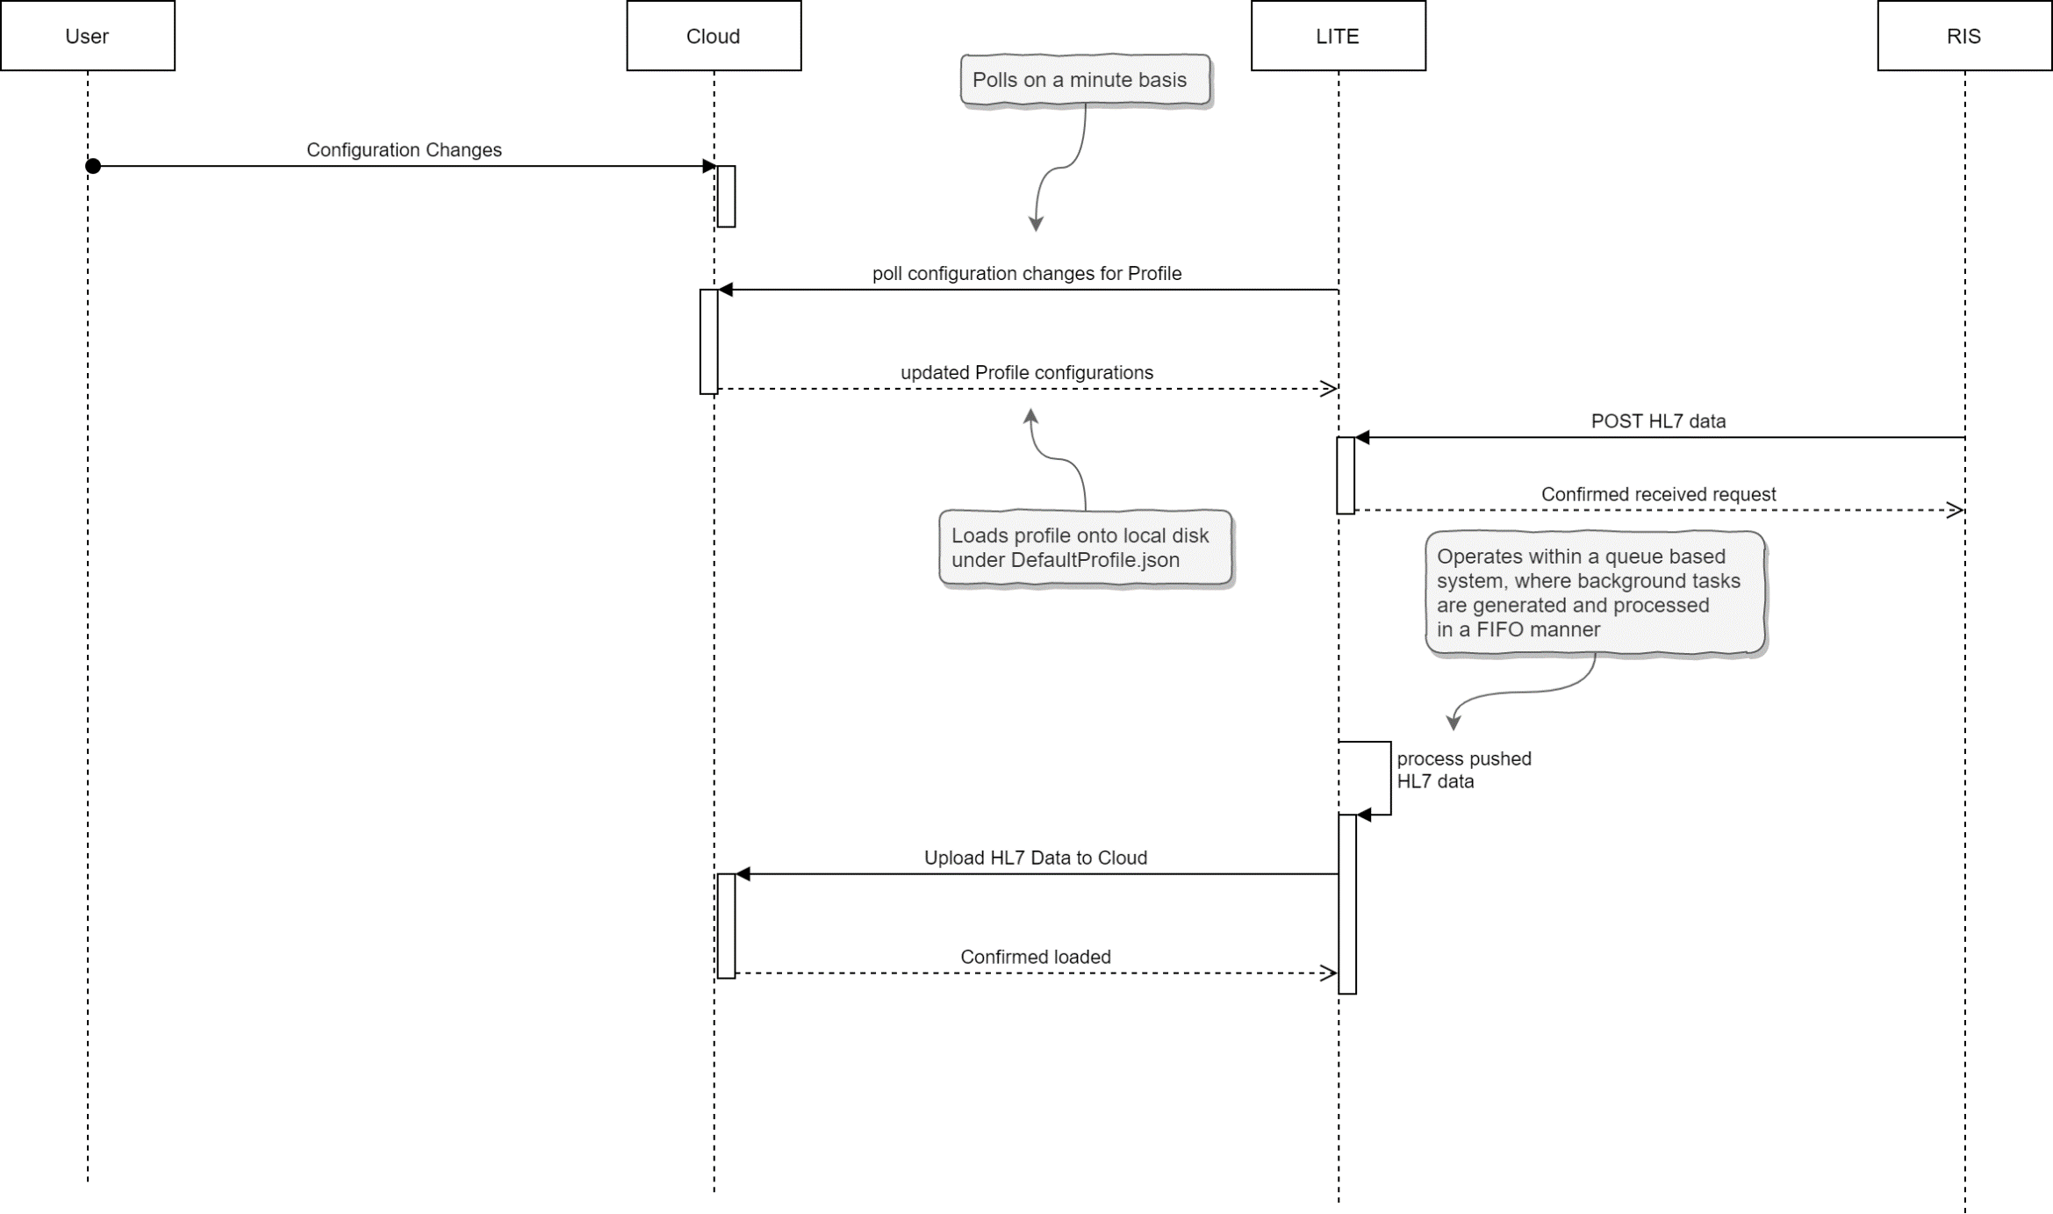

**Figure 2**: Example workflow from configuring the connections via the Profile mechanism, and pushing sample HL7 data from an RIS system

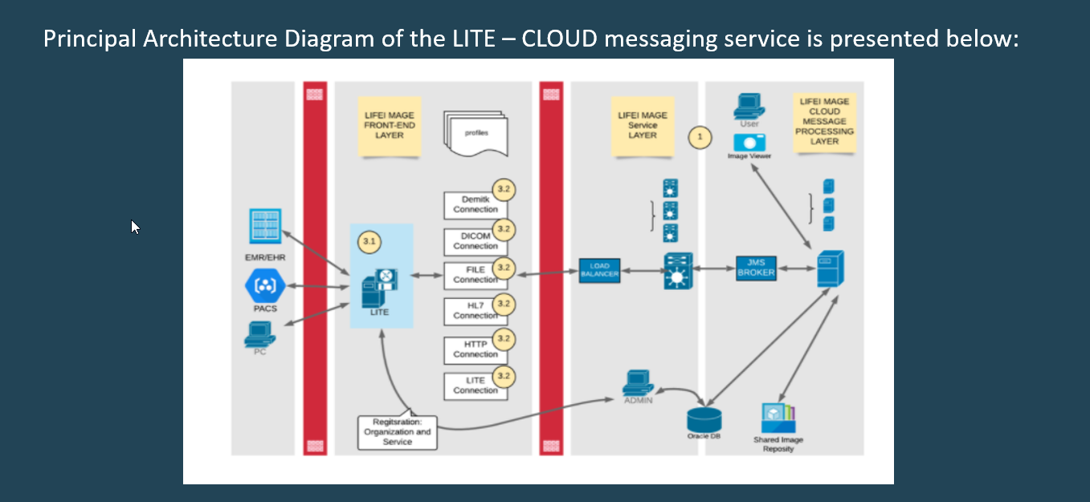

**Figure 3**: Original architectural diagram for LITE

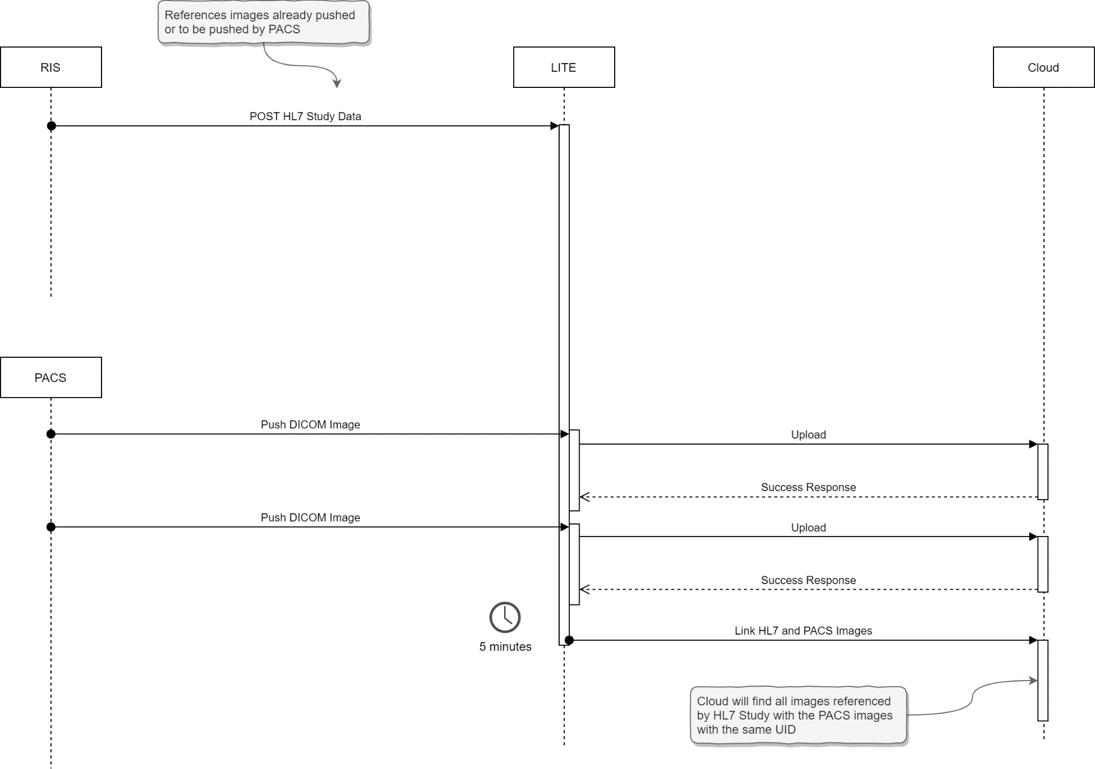

**Figure 4**: A sample upload of an HL7 study and DICOM images into a validated and closed study in Cloud

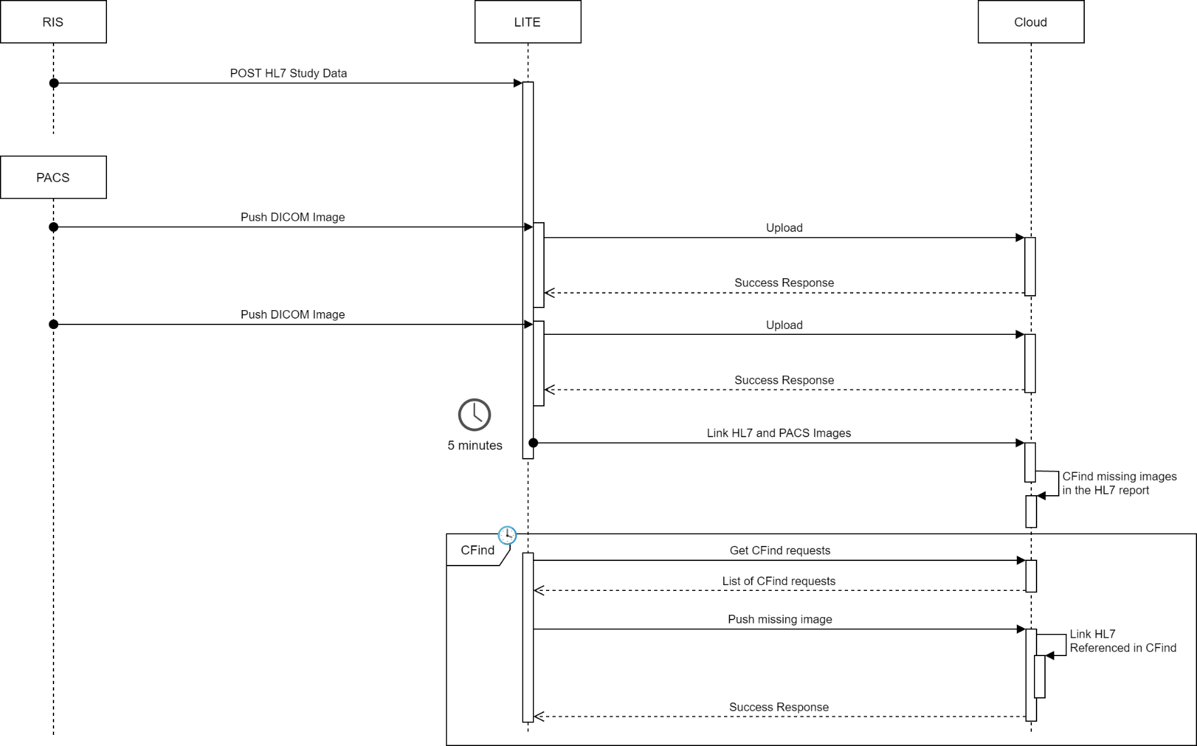

**Figure 5**: Cloud noticing missing images referenced in HL7 report, and creating CFind requests

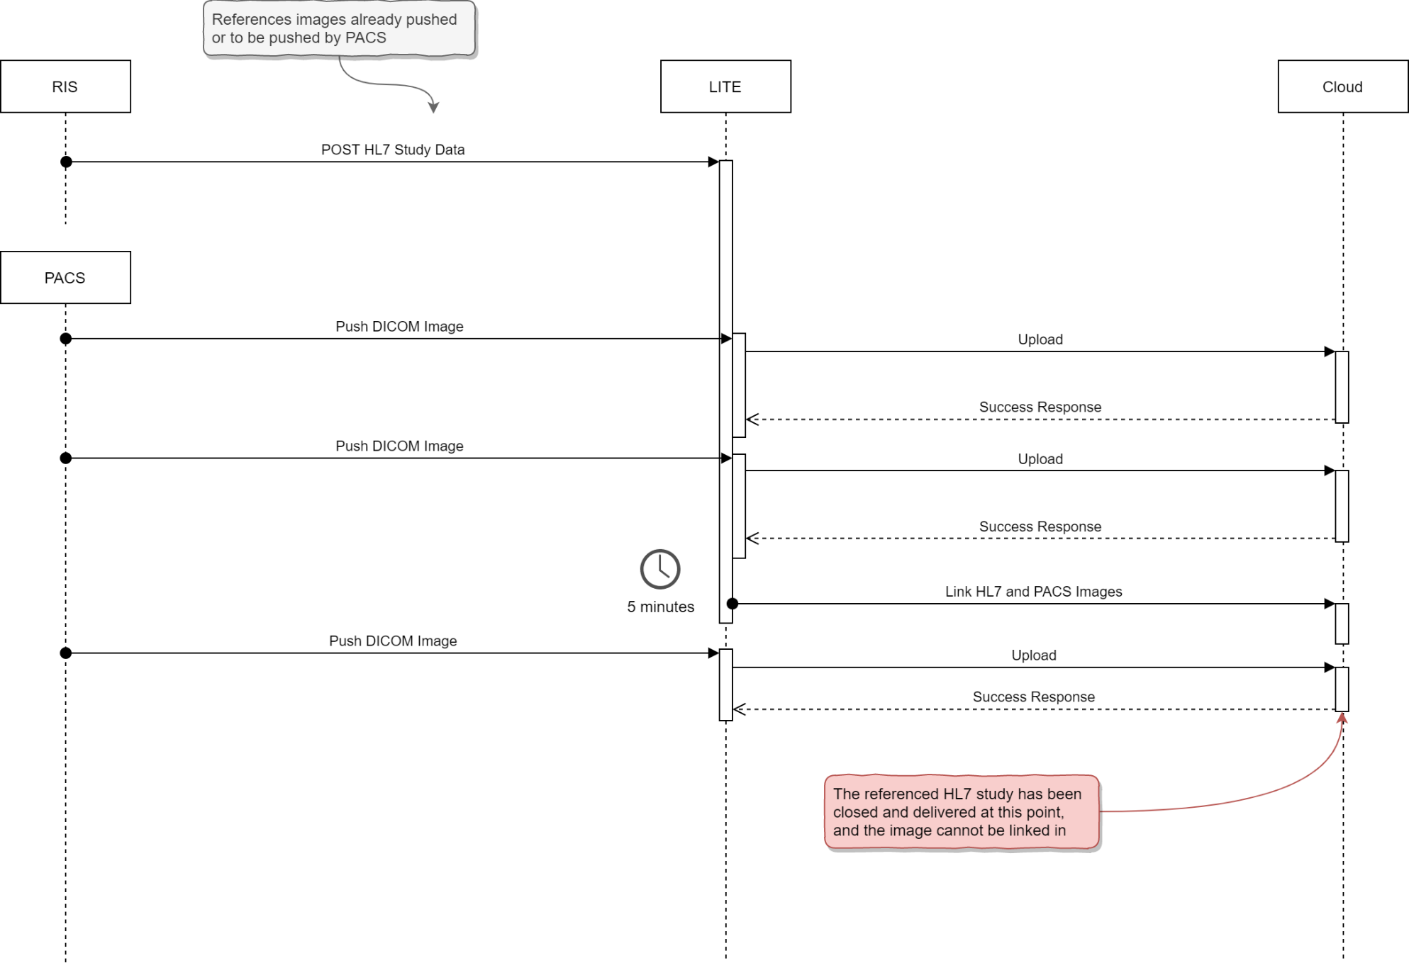

**Figure 6**: A situation in which PACS attempts to upload an image to a closed Study within Cloud

# Unknowns

There are many unknowns in the system, and after a set of interview questions and review of the documentation, it appears there are some gaps in knowledge of the internals of the system. With limited information, we can continue to dig in by going to client sites and observing operations directly.

Throughout the process of a refactor, it should be noted that documentation should play a heavy focus such that this information will be both uncovered as well as presented to the next set of developers.

# Glossary of Terms

|  |  |
| --- | --- |
| DICOM | Digital Imaging and Communications in Medicine – standard for data communication and management in medical imaging information and related data |
| DCMTK | DICOM Toolkit – A collection of tools that allows for the manipulation of DICOM data |
| HL7 | Health Level 7 – Set of international standards for transfer of clinical and administrative data |
| LITE | Life Image Transfer Exchange |
| FHIR | Fast Healthcare Interoperability Resources |
| RIS | Radiological Information System is the core system for electronic management of imaging |
| HIS | Hospital Information Systems contains hospital related electronic information |
| PACS | Picture archiving and communication system is a medical imaging storage standard |
| EMR | Electronic Medical Records is a standard for storing data |